**Assumption:**

1. **There is only one assignment in every Class Sections.**
2. **An artwork only has a corresponding instructor.**
3. **Only the instructor of the artwork can write an evaluation for the work.**
   1. **Entity:**

Staff CourseMaterial

Student Artwork

Course Evaluation

ClassSections

**Relationship:**

Staff *Teaches* Course.

Staff *Manages* ClassSections.

Staff *Maintains* CourseMaterials.

Staff *Instructs* Artwork.

Staff *Writes* Evaluation

Student *Registers* Course

Student *Creates* Artwork

Course *BelongTo* ClassSections

Course *AssociatedWith* Evaluation

CourseMaterials ConnectsTo Course

ClassSections (With Assignment) Determines Artwork.

Artwork *Has* Evaluation

Artwork *Themes* Course.

Evaluation *Assesses* Student

**Alias Form:**

|  |  |  |  |
| --- | --- | --- | --- |
| Entity name | Description | Aliases | Occurrence |
| Staff | General term describing all staff employed by *Creative Art* | Teacher | Each staff teaches zero or more courses, manages zero or more class sections and course materials. |
| Instructor | Each staff instructs zero or more student’s artwork and writes zero or more evaluations. |
| Author | Each staff creates zero or more course materials. |
| Student | General term describing all students studying in *Creative Art* | Artist | Each student creates zero or more artwork. |
| Course | This entity represents the various online design courses offered. | Course | Each course can have zero or more class sections |

1.2 **Relationship Form:**

|  |  |  |  |  |
| --- | --- | --- | --- | --- |
| Entity name | Multiplicity | Relationship | Multiplicity | Entity name |
| Staff | 1..* | Teaches | 0..* | Course |
| 1..1 | Manages | 0..* | ClassSections |
| 1..1 | Maintains | 0..* | CourseMaterials |
| 1..1 | Instructs | 0..* | Artwork |
| 1..1 | Writes | 0..* | Evaluations |
| Student | 1..1 | Creates | 0..* | Artwork |
| 0..* | Registers | 0..* | Course |
| Course | 1..* | BelongTo | 1..* | ClassSections |
| 1..1 | AssociatedWith | 1..* | Evaluations |
| ClassSections | 1..1 | Determines | 0..* | Artwork |
| CourseMaterials | 0..* | ConnectsTo | 1..1 | Course |
| Artwork | 1..* | Themes | 1..1 | Course |
| Artwork | 1..1 | Has | 0..1 | Evaluation |
| Evaluation | 0..* | Assesses | 1..1 | Student |

1.3 **Variables Type Form:**

|  |  |  |  |  |  |  |
| --- | --- | --- | --- | --- | --- | --- |
| Entity name | Attributes | Description | Data Type & Length | Nulls | Unique | Primary Key |
| Staff | staffNo | Staff code, a unique identifier for each staff member | CHAR(8) | No | Yes | Yes |
| name | name of the staff member | VARCHAR(70) | No | No | No |
| fName | First name of the staff member | VARCHAR(30) | No | No | No |
| lName | Last name of the staff member | VARCHAR(30) | No | No | No |
| status | status of the staff (enabled or banned) | CHAR(1) (1 - enabled/0 - banned) | No | No | No |
| sex | Gender of the staff member | CHAR(1) (M/F) | No | No | No |
| address | Address of the staff memberAddress of the staff member | VARCHAR(16) | No | No | No |
| phone | Phone number of the staff member | CHAR(14) | No | No | No |
| id | Staff member's unique identification (ID) number | CHAR(18) | No | Yes | No |
| birth | Date of birth of the staff member | DATE | No | No | No |
| expertise | Area of expertise of the staff member | VARCHAR(10) | No | No | No |
| email | Email address of the staff member | VARCHAR(100) | No | No | No |
| Student | studentNo | Student code, a unique identifier for each student | CHAR(8) | No | Yes | Yes |
| name | name of the student | VARCHAR(70) | No | No | No |
| fName | First name of the student | VARCHAR(30) | No | No | No |
| lName | Last name of the student | VARCHAR(30) | No | No | No |
| id | Student's unique identification (ID) number | VARCHAR(30) | No | Yes | No |
| address | Address of the student | VARCHAR(255) | No | No | No |
| sex | Gender of the student | CHAR(1) (M/F) | No | No | No |
| phone | Phone number of the student | VARCHAR(16) | No | No | No |
| birth | Date of birth of the student | DATE | No | No | No |
| major | Major or field of study for the student | VARCHAR(50) | No | No | No |
| email | Email address of the student | VARCHAR(100) | No | No | No |
| Course | courseNo | Course code, a unique identifier for each course | CHAR(50) | No | Yes | Yes |
| name | Name of the course | VARCHAR(30) | No | No | No |
| description | Description of the course | VARCHAR(50) | Yes | No | No |
| pre | Prerequisites or preparation information for the course | VARCHAR(50) | Yes | No | No |
| Staff_Course_Link[1] | staffNo | Staff code, linked to staff information | CHAR(8) | No | No | Yes |
| courseNo | Course code, linked to course information | CHAR(50) | No | No | Yes |
| Student_Course_Registration[2] | studentNo | Student code, linked to student information | CHAR(8) | No | No | Yes |
| courseNo | Course code, linked to course information | CHAR(50) | No | No | Yes |
| enroll_date | Enrollment date for the course | DATETIME | No | No | No |
| ClassSection | sectionNo | Section code, a unique identifier for each section | CHAR(100) | No | Yes | Yes |
| associated_course | Course code associated with the section | CHAR(50) | No | No | No |
| section_duration | duration of the class | CHAR(21)  (yyyy/MM/dd-yyyy/MM/dd) | No | No | No |
| section_day | day of the class | CHAR(3)  (Mon/Tue/Wed/  Thu/Fri/Sat/Sun) | No | No | No |
| section_time | time of the class | CHAR(11)  (HH:mm-HH:mm) | No | No | No |
| section_instructor | Staff code of the instructor for the section | CHAR(5) | No | No | No |
| assignment | Course assignments or homework | VARCHAR(255) | Yes | No | No |
| section_semester | Semester during which the section is offered | CHAR(1) (1/2) | No | No | No |
| section_year | Year in which the section is conducted | YEAR | No | No | No |
| CourseMaterial | document_id | Document ID, a unique identifier for each document | VARCHAR(36) | No | Yes | Yes |
| document_title | Title of the document | VARCHAR(100) | No | No | No |
| document_topic | Topic of the document | VARCHAR(100) | No | No | No |
| associated_course | Course code associated with the document | CHAR(50) | No | No | No |
| document_author | Author of the document | VARCHAR(0) | No | No | No |
| created_time | Date and time of document creation | DATETIME | No | No | No |
| modified_time | Date and time of document modification | DATETIME | No | No | No |
| Artwork | artworkNo | Artwork code, an auto-incremented unique identifier for each artwork | INT | No | Yes | Yes |
| name | Name of the artist who created the artwork | VARCHAR(30) | No | No | No |
| format | Format of the artwork (e.g., JPEG, PDF) | VARCHAR(5) | No | No | No |
| created_time | Date and time of artwork creation | DATETIME | No | No | No |
| submitted_time | Date and time of artwork submission | DATETIME | No | No | No |
| used_medium | Medium or materials used in the artwork | VARCHAR(50) | No | No | No |
| subject | Subject or content of the artwork | VARCHAR(255) | Yes | No | No |
| associated_course | Course code associated with the artwork | CHAR(50) | Yes | No | No |
| associated_instructor | Staff code of the instructor | CHAR(5) | No | No | No |
| associated_section[3] | Indicates the assignment or the coursework stated in ClassSections table | CHAR(100) | Yes | No | No |
| Evaluation | associated_artwork | Artwork code associated with the evaluation | INT | No | Yes | Yes |
| written_date | Date and time when the evaluation was written | DATETIME | No | No | No |
| grade | Grade or score given in the evaluation | CHAR(5) | No | No | No |
| remark | Comments or feedback provided in the evaluation | VARCHAR(255) | Yes | No | No |

**The evaluation depends on artwork table. So we consider that** ***Evaluation table should not have associated student, associated instructor, associated course and associated assignment,* which are all included in the artwork table.**

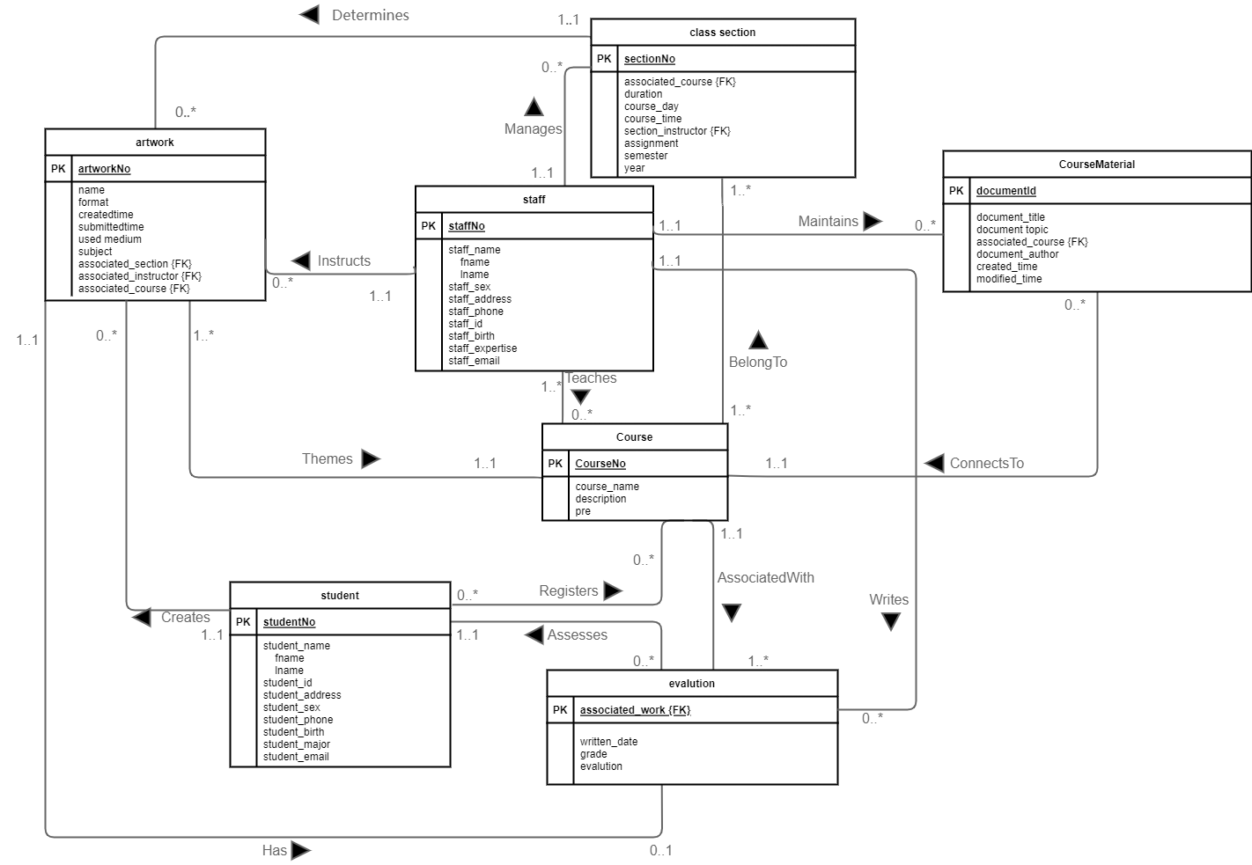

1. Staff_Course_Link: A table that deals with the many-to-many relationship between the teacher and the course
2. Student_Course_Registration: A table that records the classes students are or were enrolled in
3. associated_section: A foreign key which indicates asscociated assignment